**Assignment -12 Coding Practice**

1. Write a function to find out the given number iseven or not.

Coding:

const number=prompt("Enter a Number:");

if(number%2==0)

{

console.log("the given number is even.");

}

else

{

console.log("the given number is not even.") ;

}

Output:

Enter a Number:89

the given number is not even

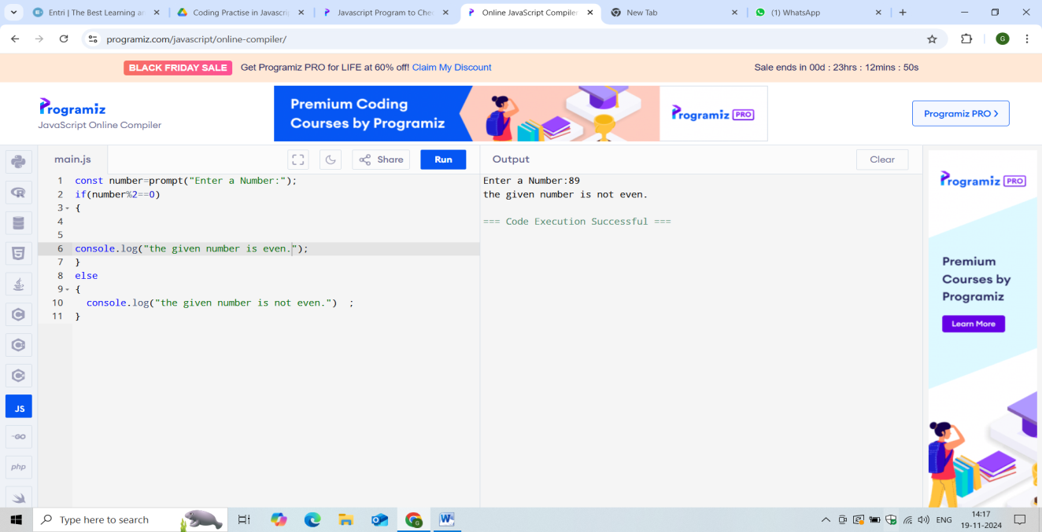

2.Write a Arrow function to print your name as 5times.

CODING:

let name = "EntriElevate";

let repeatCount = name.repeat(5);

console.log(repeatCount);

OUTPUT:

EntriElevate

EntriElevate

EntriElevate

EntriElevate

EntriElevate

SCREENSHOT:

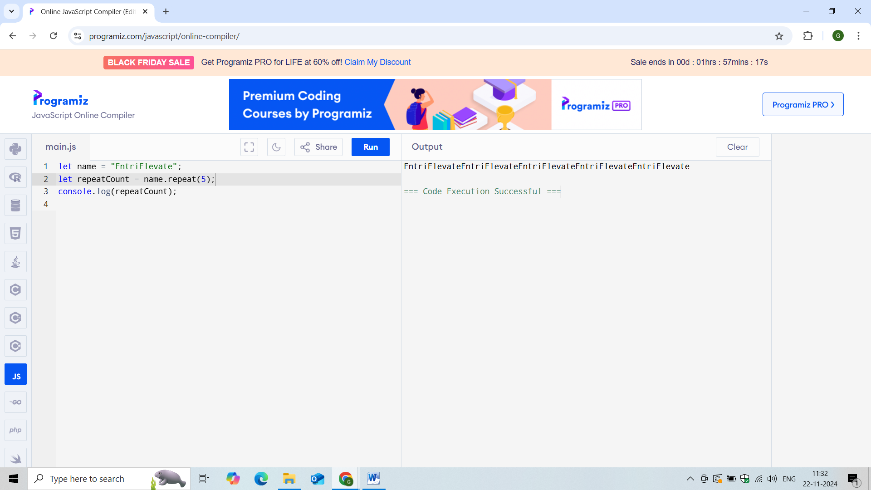

3.Write a function to get the string from user and change it as uppercase and lowercase.

CODING:[UpperCase]

let text = "Hello Entri!";

let result = text.toUpperCase();

console.log(result)

CODING:[Lowercase]

let text = "Hello Entri!";

let result = text.toLowerCase();

console.log(result)

OUTPUT:[Uppercase]

HELLO ENTRI!

OUTPUT:[LowerCase]

Hello entri!

SCREENSHOT:

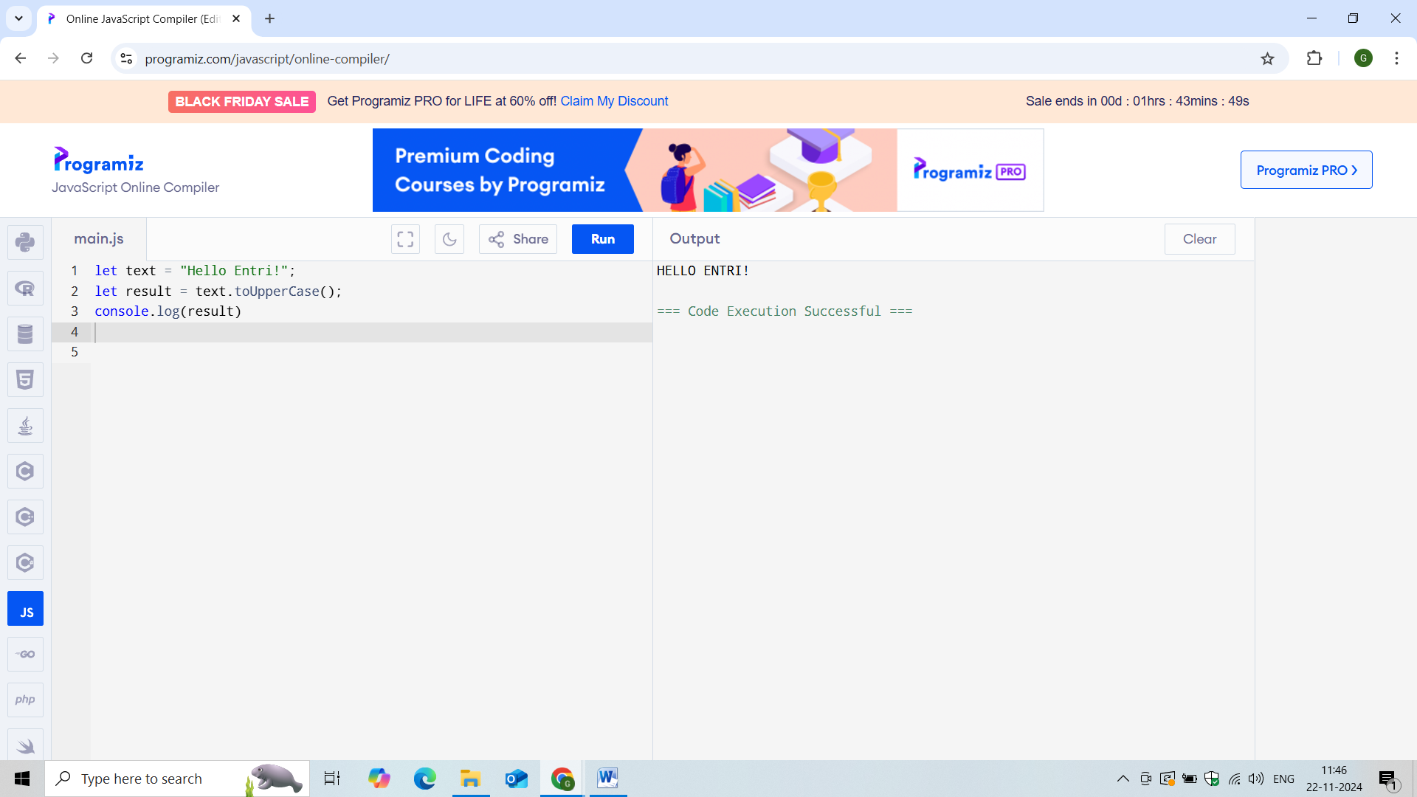

4.Find out the factorial of the given number:

Coding:

function fact(n)

{

let res=1;

if(n===0)

return 1;

for(let i=2;i<=n;i++)

res=res*i;

return res;

}

let n=prompt("Enter a Value:");

console.log(fact(n)+" is a factorial of a given number.");

Output:

Enter a Value:3

6 is a factorial of a given number.

Screenshot:

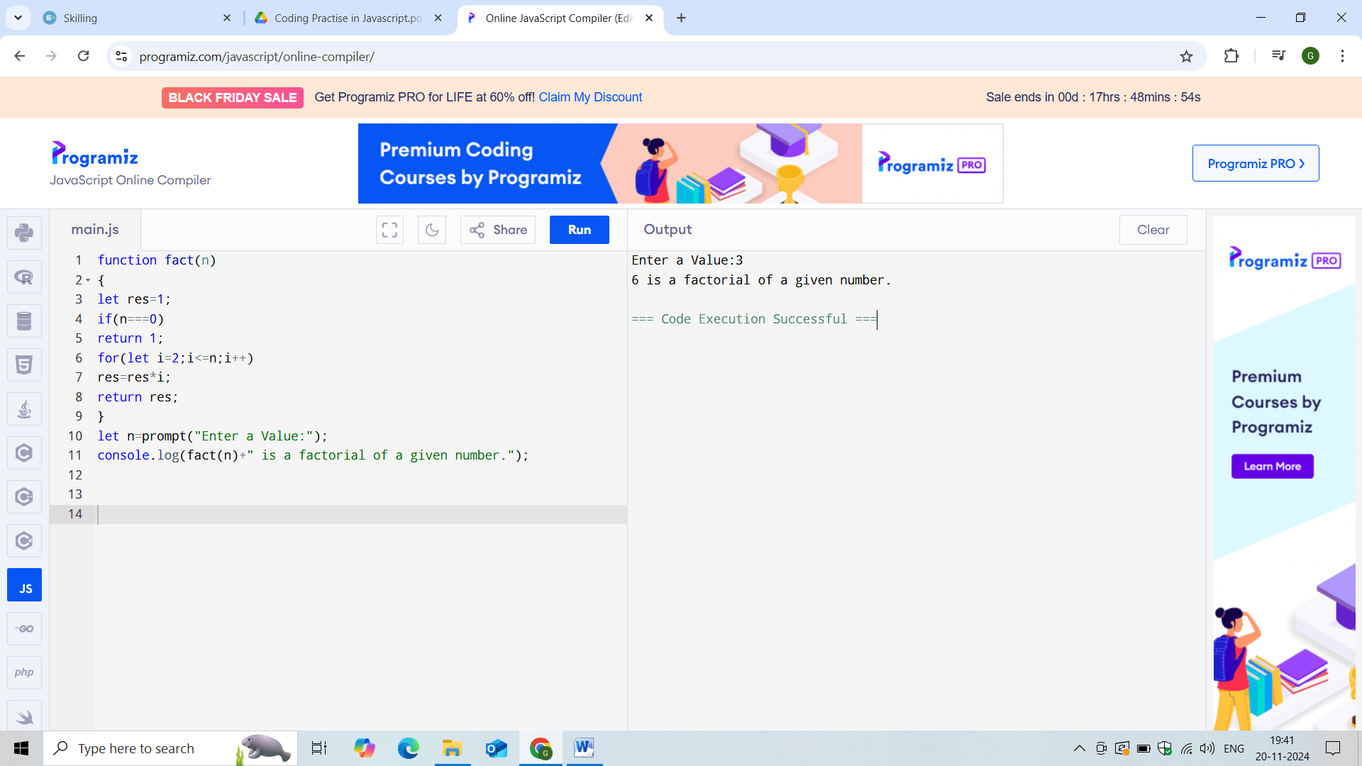

5. Get the String from the user and find out the count of vowel letters in the string.

CODING:

function isVowel(ch)

{

ch = ch.toUpperCase();

return ch == "A" || ch == "E" || ch == "I" || ch == "O" || ch == "U";

}

function countVowels(str)

{

var count = 0;

for (var i = 0; i < str.length; i++)

if (isVowel(str[i]))

++count;

return count;

}

var str="count";

document.write(countVowels(str));

output:

2

SCREENSHOT:

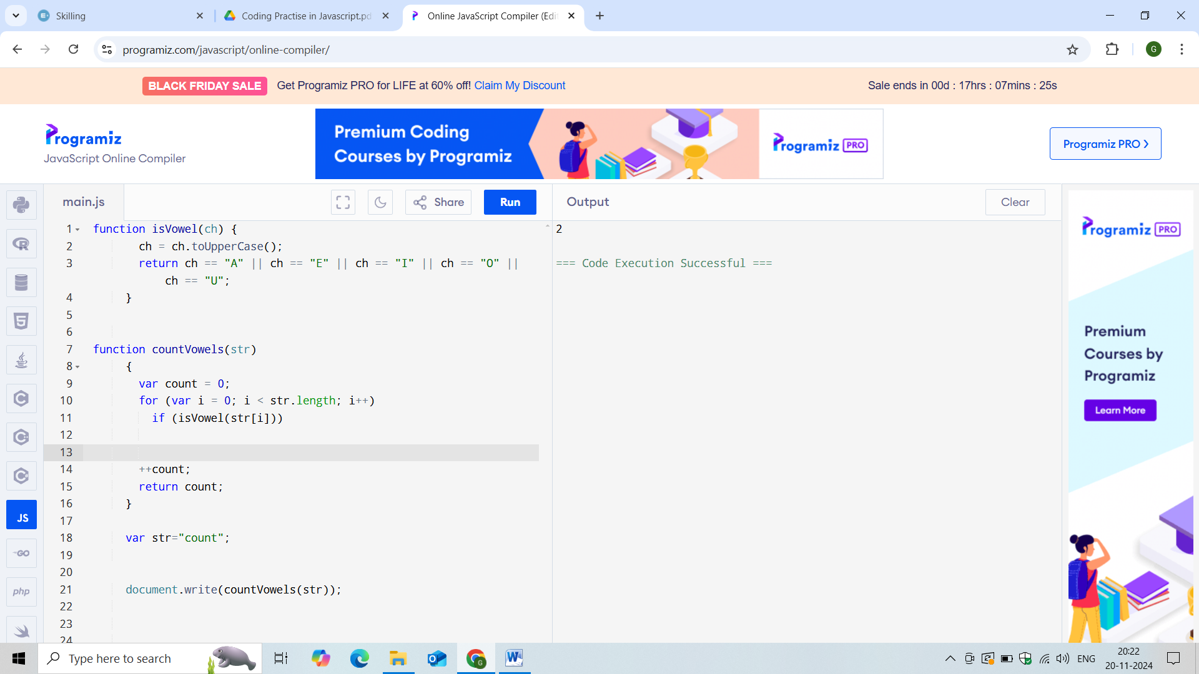

6. Insert a new element in the array.

Const a1=[23,45,89,22,77,09]

Add the new numbers to the array

Delete the last number from the given array.

CODING:[Add the element]

const a1=[23,45,89,22,77,09];

a1.push(80);

console.log(a1);

OUTPUT:[Add the number]

[

23, 45, 89, 22,

77, 9, 80

]

SCREENSHOT:

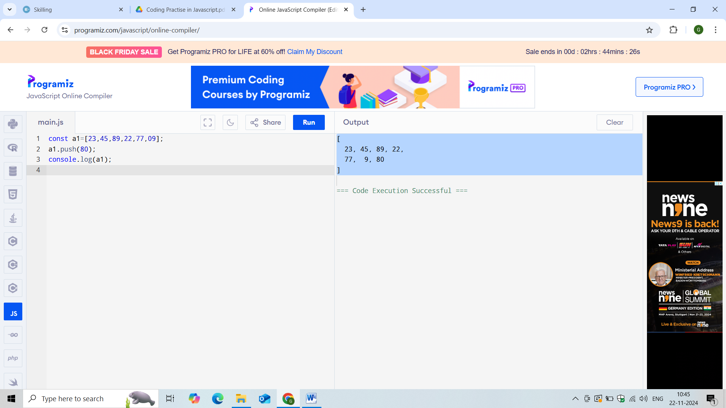

6.Delete the last element in an array:

CODING:

const a1=[23,45,89,22,77,09] ;

console.log("Original Array:", a1);

let elemsToDelete = 3;

while (elemsToDelete--)

a1.pop();

console.log("New Array:", a1);

OUTPUT:

Original Array: [ 23, 45, 89, 22, 77, 9 ]

New Array: [ 23, 45, 89 ]

SCREENSHOT:

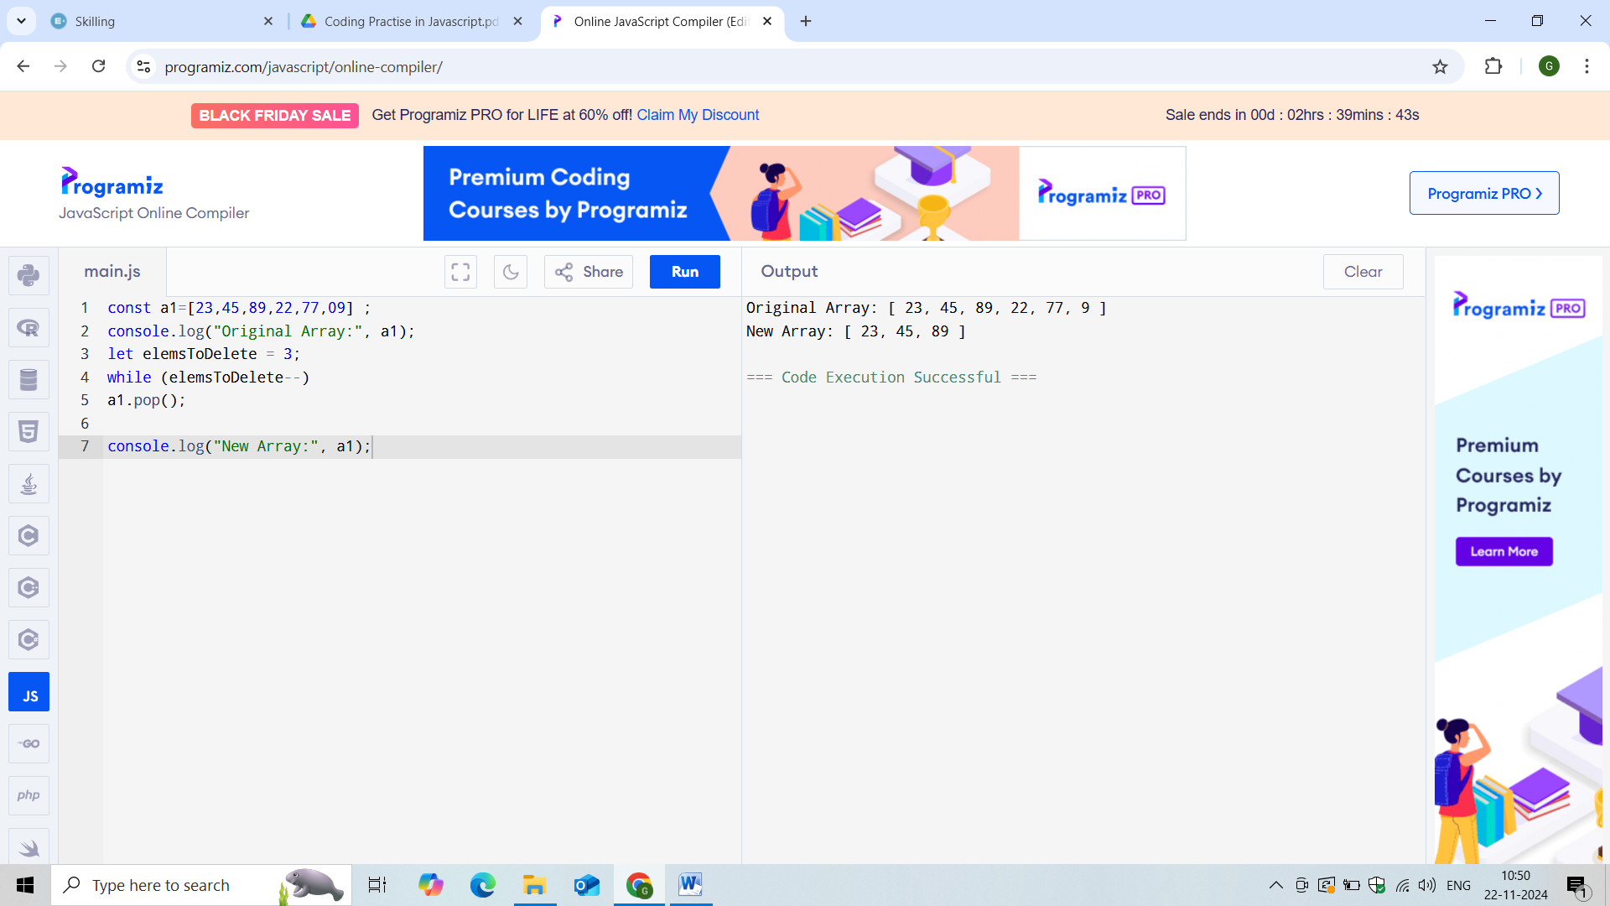

7. Write a table for 8th table. Like this format (1 X 8 = 8)

CODING:

let n = 8;

let range = 6;

for (let i = 1; i <= range; ++i)

console.log(n + " * " + i + " = " + n * i);

OUTPUT:

8 * 1 = 8

8 * 2 = 16

8 * 3 = 24

8 * 4 = 32

8 * 5 = 40

8 * 6 = 48

SCREENSHOT:

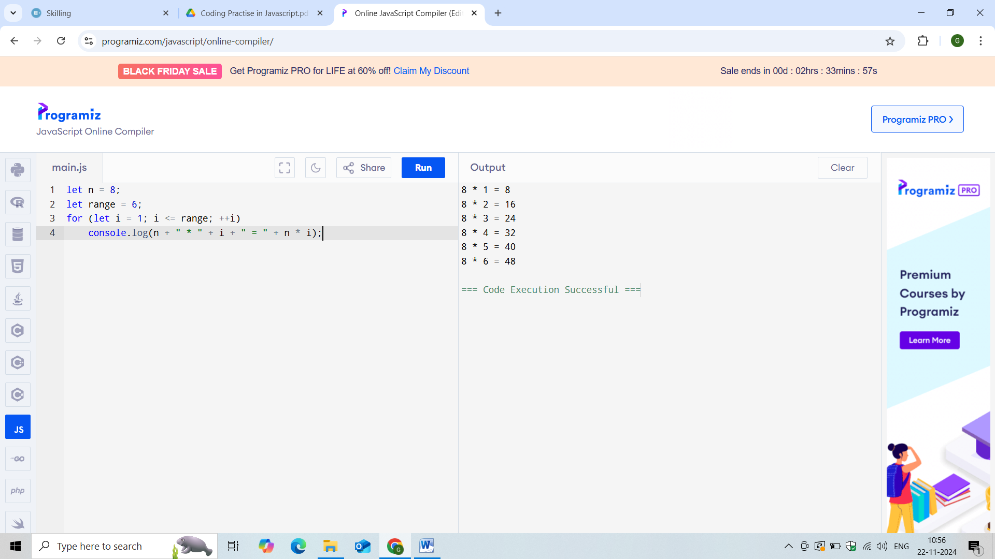

8. Let text=”I am a front end developer” Replace the text “fronend” to “Full Stack”

CODING:

let str1 = 'Front end';

let str2= str1.replace('Front end', 'Fullstack');

console.log(str2);

OUTPUT:

Fullstack

SCREENSHOT:

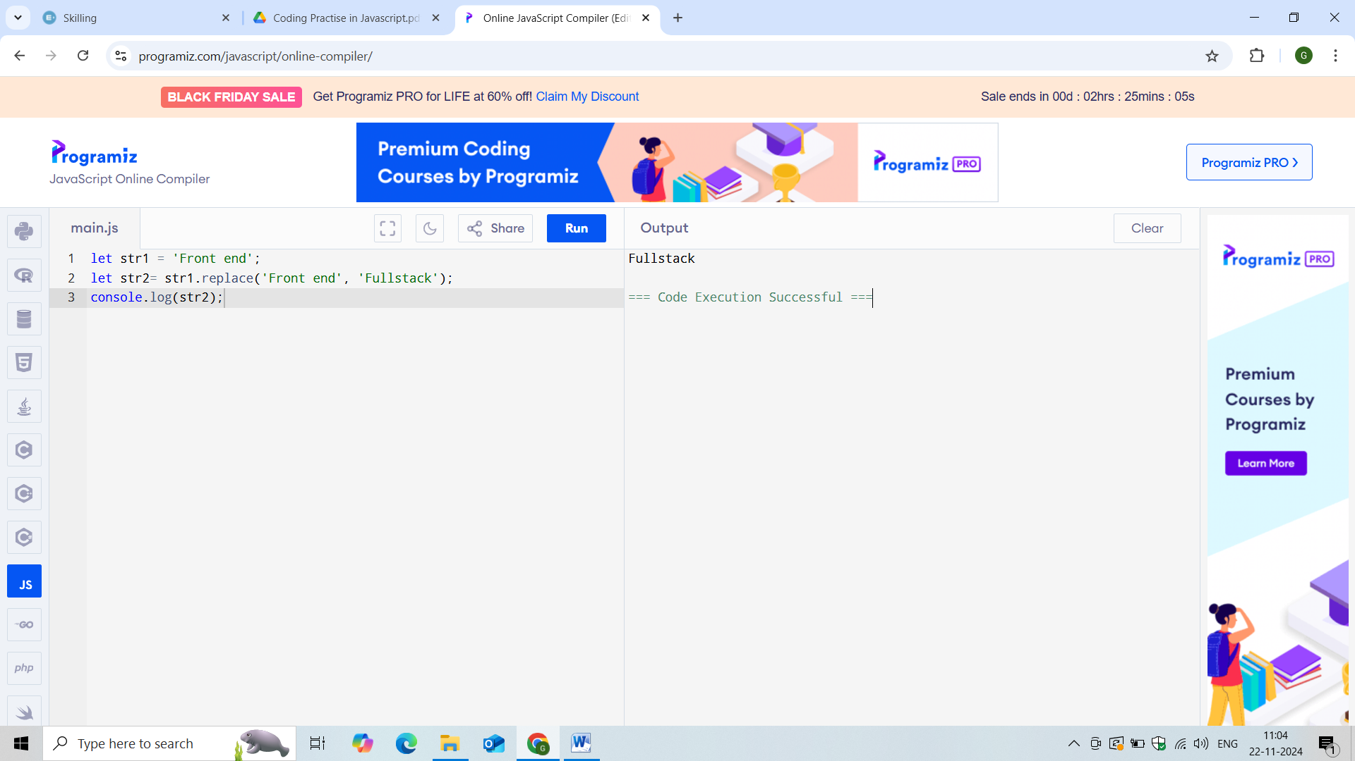

9. Write a function to find out the given number is divisible by 6.

CODING:

var n =666

if (n % 6 == 0)

document.write("The given number is divisible by 6")

else

document.write("The given number is not divisible by 6")

OUTPUT:

The given number is divisible by 6

SCREENSHOT:

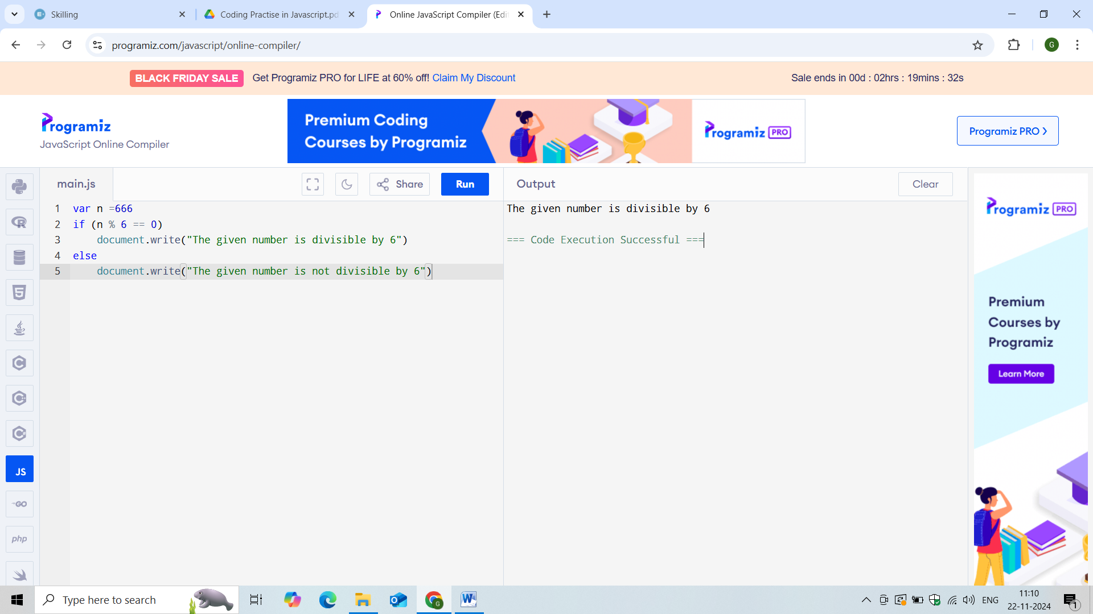

10.Write a function to print today date.

CODING:

let date = new Date();

let todaydate = date.toDateString();

console.log(todaydate);

OUTPUT:

Fri Nov 22 2024

SCREENSHOT:

